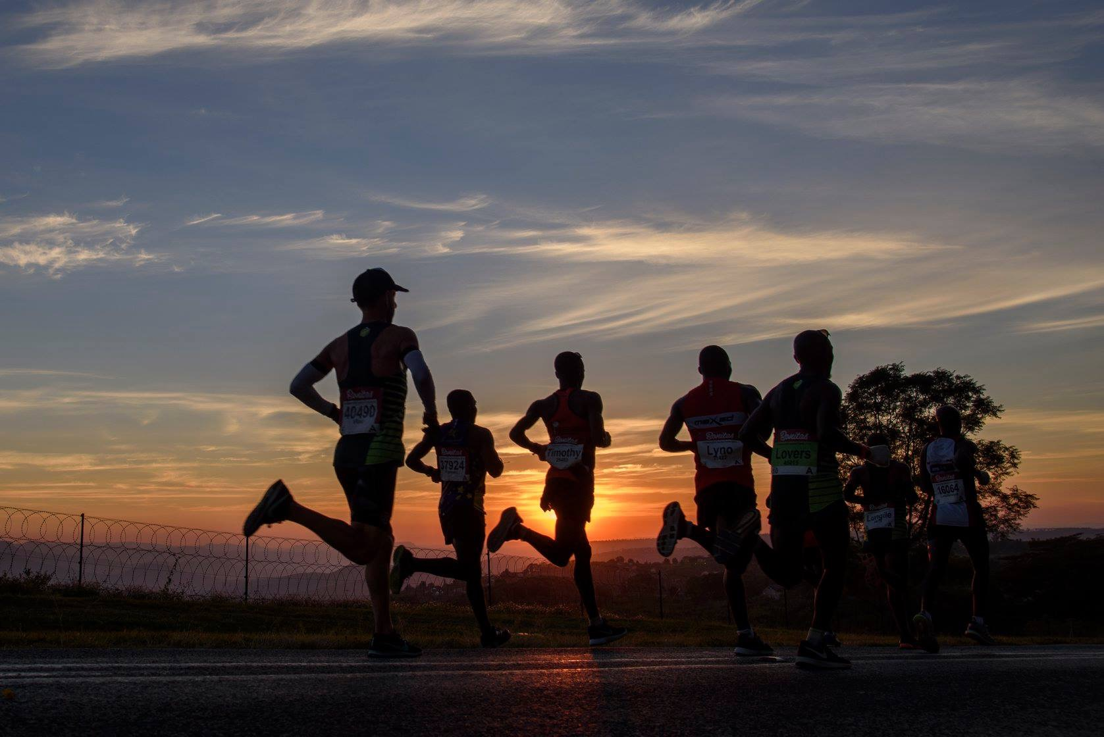

Finally light! This photo must have been taken about 15km into the race, it was nice to see!

Brace and fall…… except there was no graceful landing and little if any bracing. At the 70km point I hit the deck. Hard enough to momentarily shock me as I was dragged back onto my feet by two very helpful bystanders. The team support crew had somehow managed to trip me up as I came into grab one of my drinks, this was at a particularly challenging section of the run at the base of another steep hill. I actually cannot remember exactly what happened in those few minutes, but I don’t think I ended up getting my drink. I do remember thinking this could be my race over. I was in a lot of pain and when I fell my body just sort of ceased up momentarily, regardless once on my feet I was determined to keep pushing. A walk turned into a shuffle and then in response to the encouragement of the large crowd gathered around this major 7okm mark, a shuffle turned into a very slow run. I willed myself just to get to the top of this hill, about another 200 metres or so. I couldn’t loose too much time, getting to the top of that hill was my only desire, once there Id be able to determine if I could actually run and continue on to finish in a respectable time. It seemed like forever but I got there and quickly as it flattened out, my running stride returned to almost normal and shortly after on a slight descent I was back into rhythm and pace. In that moment of total relief I realised Id be able to run well to the end .I had hit the ground with both knees, hands and my elbow simultaneously and as I tried to get back into my stride blood was streaming down my left forearm from the palm of my hand and my knees felt bloody sore.

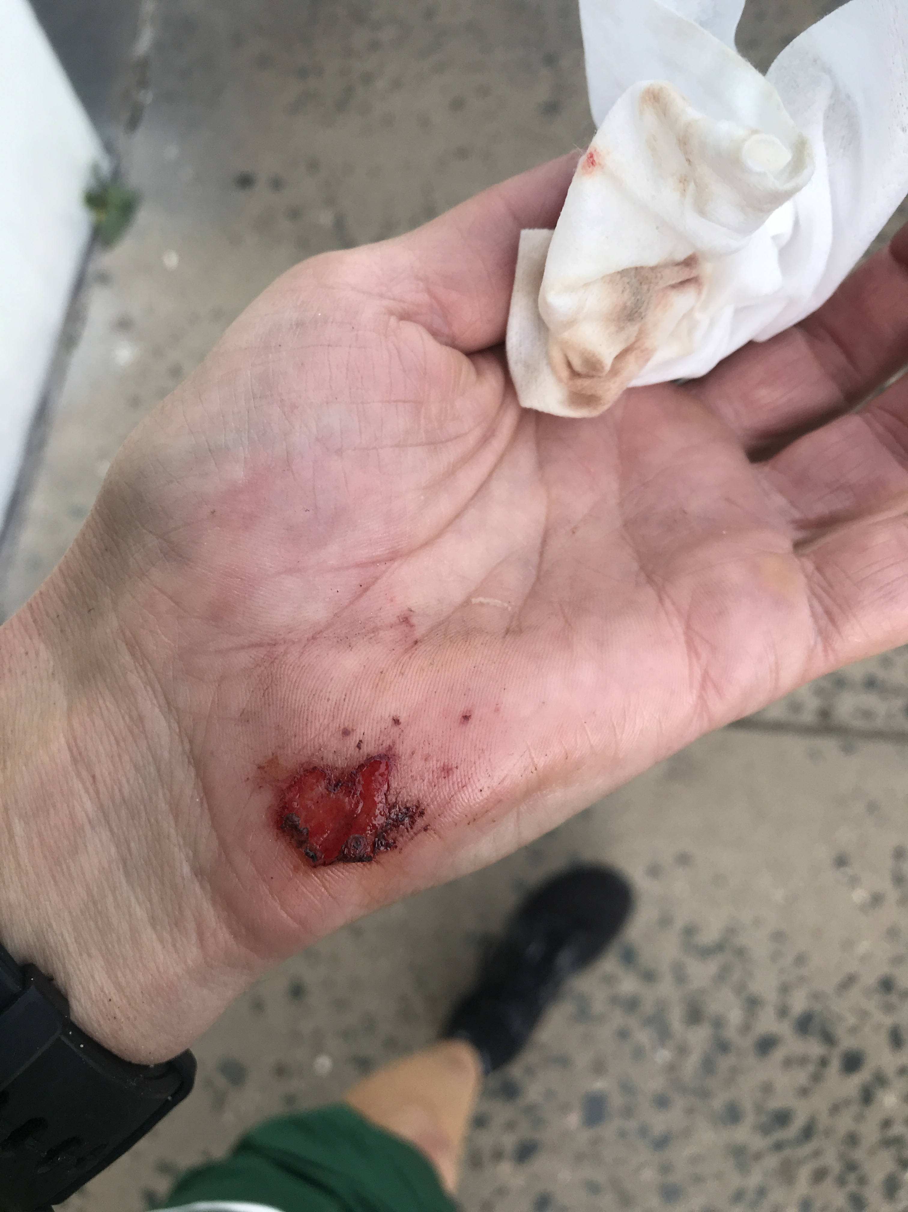

Not large at all but the main source of pain.

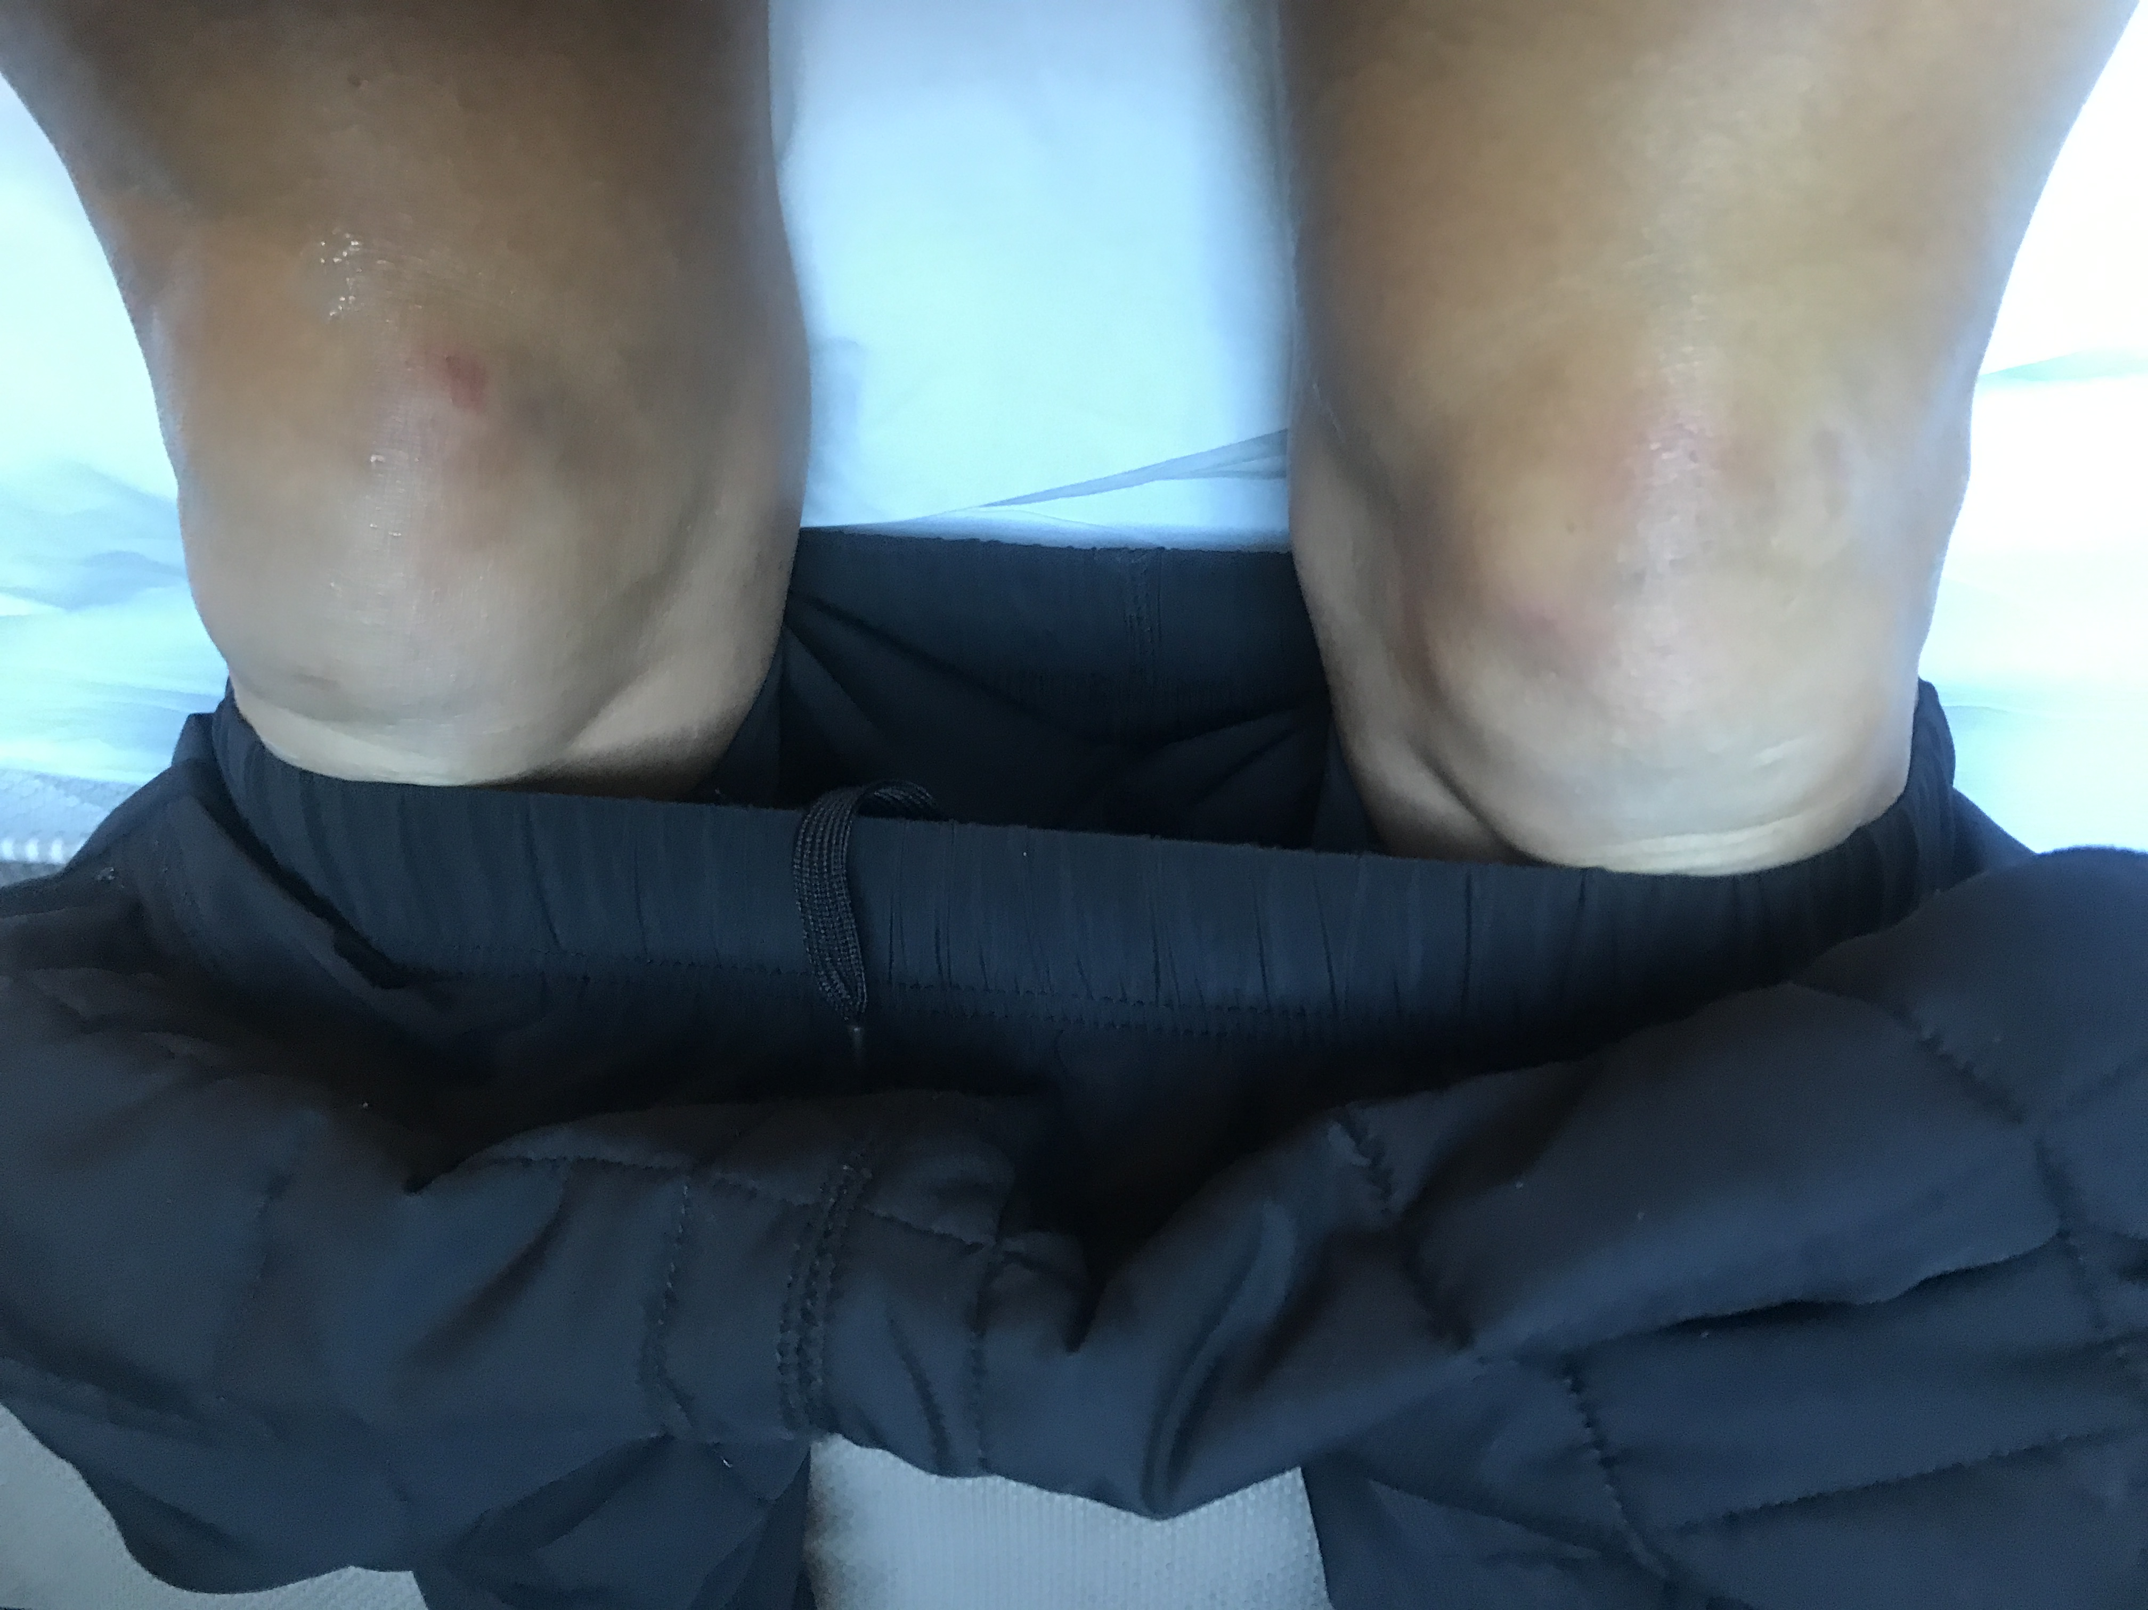

Race day evening, just some bruised knees

I apologise in advance, my race reports often contain unnecessary detail not interesting to everyone’s tastes, they do help me however prepare for future events which is why I like to try and add the key details.

We arrived in Durban late on the Tuesday evening before the race. So we had 4 full days to unwind and prepare. It turned out to be the perfect amount of time to arrive before a major event to settle into the local time zone and get rested and prepared. Some local travel, expo visits the Umlunga parkrun together with some final runs was what we did. I also had a little bit of work to deal with and shut out as best I could.

Running the parkrun the day before actually worked out well. Friday (The day before) was a complete non run day, Wednesday I did an easy run of 14km in total and on Thursday I did a run of 11km which included 3 times 4 minutes and 1 times 5 minutes at target race pace or slightly faster followed quickly by 4*30 seconds hard. It didn’t feel easy but it didn’t feel hard – however post session I felt energetic and pleased I had done it. We also ran the local Parkrun. Each km was about 10 seconds faster than the previous and on a narrow packed course this ended up being a great final flush! 18:28 for 5km when in the past I would have worries about running at all. I started easy and just picked it up along the way.

The rest of race evening was BORING of course – it’s the worst part of racing, the feeling of being couped up and contained, preserving yourself for the battle ahead. I focussed on getting organised early and having an uncomplicated dinner of ….. In bed by 8:30 and asleep by 9 maybe? Not a perfect sleep but I slept and when my alarm went off I was ready for the day ahead.

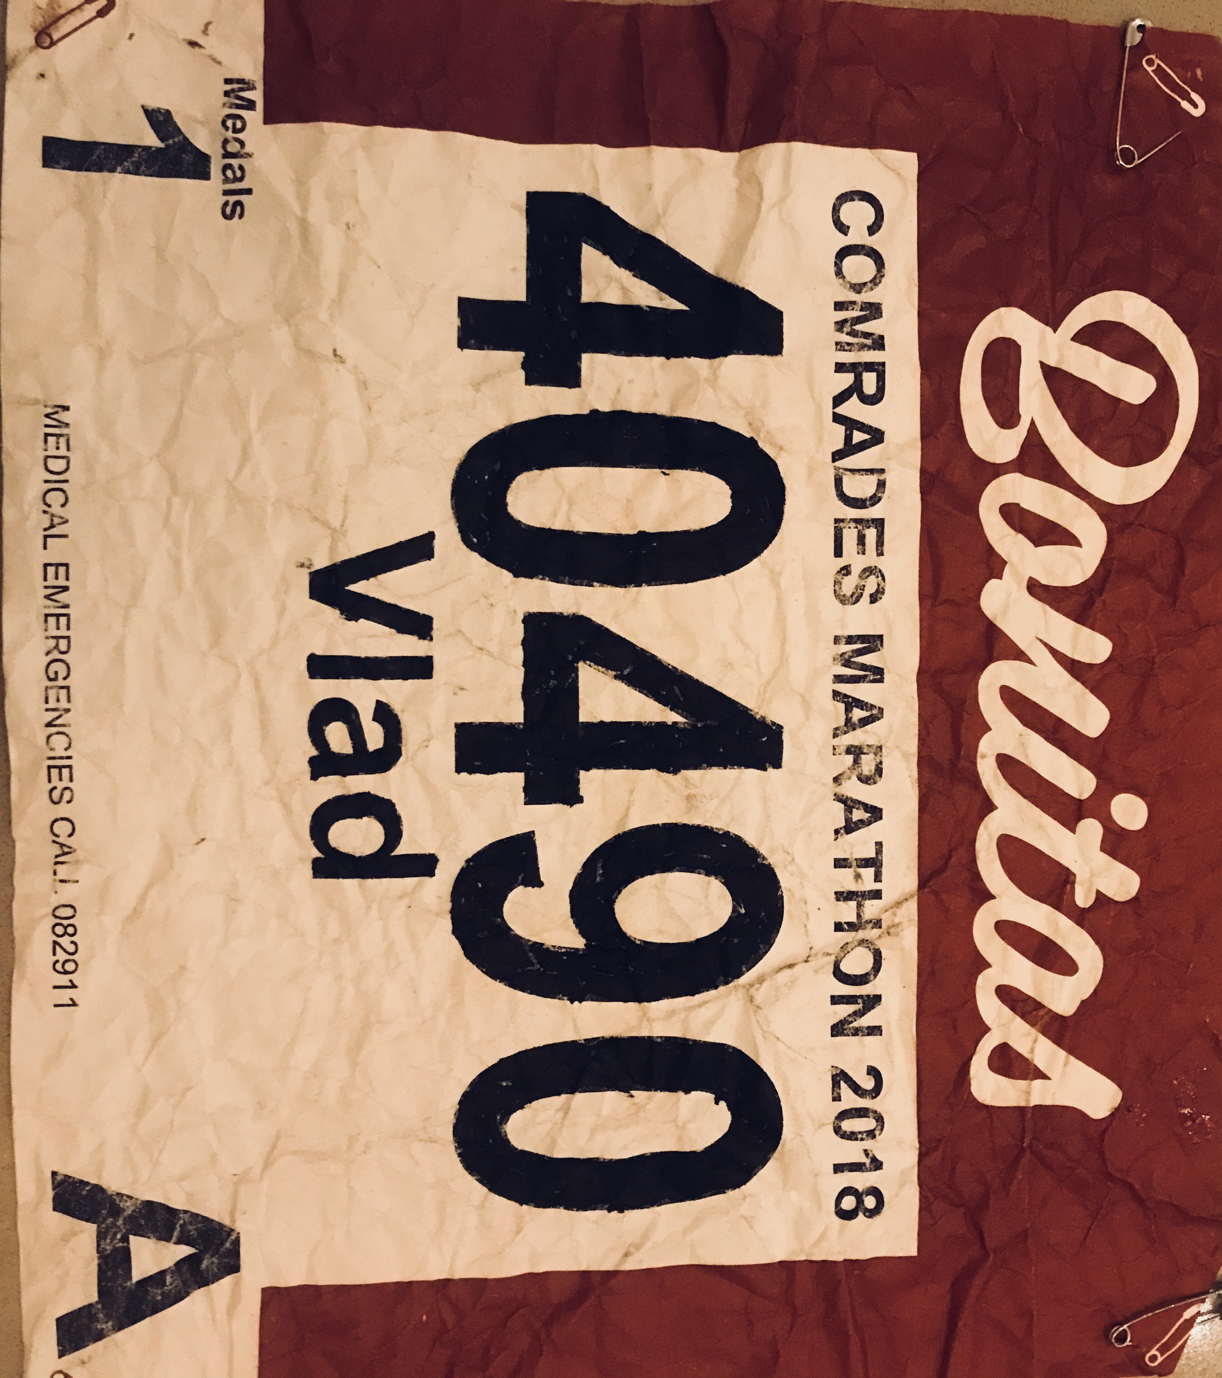
These race numbers are so large and old school. Hard, stiff paper. You must scrunch it up in a tight ball a few times over so it’s soft and pliable – unlike a piece of plywood attached to you’re front AND back. So I had to get out the black marker to recolour my number

This year’s race was the reverse of my 2017 run, and then a bit more. It had a new finishline inside the Moses Mabhida Stadium, for the first time adding some distance, but from all reports offering spectators and runners alike a much safer finish area with improved facilities.

You must accept the fact that it’s a long difficult day and just deal with the process. We were up at 1:45am and with a quick shower I was down to breakfast put on to start from 1am by the hotel we are staying at. Its no ordinary breakfast a full buffet for runners, spectators, and those working the course. For me it’s some porridge, Vegemite on Toast and a coffee!

Then it’s a 3am departure and onto one of the three NEDBANK team Vans to get to the startline at Pietermaritzburg. At this point I split from Cheryl who went on a larger Van with Terry booked through our travelling partner Run Fun Travel! We were very lucky that the team Nedbank and Run, fun travel just happen to base themselves out of the same hotel making it a seamless process for me to be with the team when required.

The drive is actually pretty eventful. Everyone is tense! Runners are chatting, some talking very loudly, drivers are constantly checking speed and progress and trying to stay in convoy. Via a special pass though we are able to drive onto the course at about the 15km mark avoiding the traffic jam heading down the only other entry road to the small city. We arrive at 4:15am and are quickly ushered into the town hall 100 metres from the start line.

Inside this nice old hall, nostalgic and full of character it’s a step back in time, I’m grateful to have any sheltered space to use bathroom facilities and do a small warm-up. Team managers are on edge and buzzing around with final logistics and instructions, runners get more and more jumpy. It’s critical to stick to your game plan, stay relaxed and then be ready to be lead to the startline with minimal fuss.

This start line is like no other. Partly the logistics and the geography and then the history of this event. With 10 minutes to go, the music starts with the South African national Anthem followed by chariots of fire – the cock crows 3 times then there is silence for 10 seconds before the gun goes off and the race surges into life. The tension until this point builds and builds , the smells the body odour , discarding of old clothes or the nappy like disposable warm-up top issued at race check in, all familiar reminders to the senses of 2017. The first few hundred metres are about breaking into space and not getting trampled. Don’t forget it’s an hour before first light still, maybe 4 degrees and over 90km to the finishline in Durban.

I was completely relaxed about my race strategy, the actual route is so undulating, so pace cannot be relied on as a guide. This isn’t to be confused with complacency though, I was focussed on a solid performance and in those first few kilometres getting into a comfortable rhythm and not falling over was key for me. Its pretty much darkness for about the first hour. Supporter’s fires and occasional streetlights and other safety lights on the edge of the road make it runnable. There is a spattering of runner’s spectators but not many yet; the sounds you hear are mainly feet, watch lap beeps and some occasional random words between runners.

On the flat and downhills, I was feeling so comfortable and would easily pickup distance on the runners around me, who would then mostly pull away, ever so slightly on the next uphill, mostly though I knew they were all working harder than me because I could hear their breathing whilst I was just floating along. Still though it was very early days and whilst I knew I was in the main front pack, I couldn’t tell how large this was and neither could I know how many runners had broken off the front and how far ahead they were.

This is how the first 18km or so went, undulation after undulation until we hit our first longer hill of 3 kilometres or so, just as daylight was taking effect. I could still see the very front pack of runners and vehicles at this point (flashing lights) but there was simply no way of really knowing position at all – from the start line I felt like I was in a pack maybe some 200 strong, come to think of it I never once the whole run looked back over my shoulder, so I really had no idea where I was.

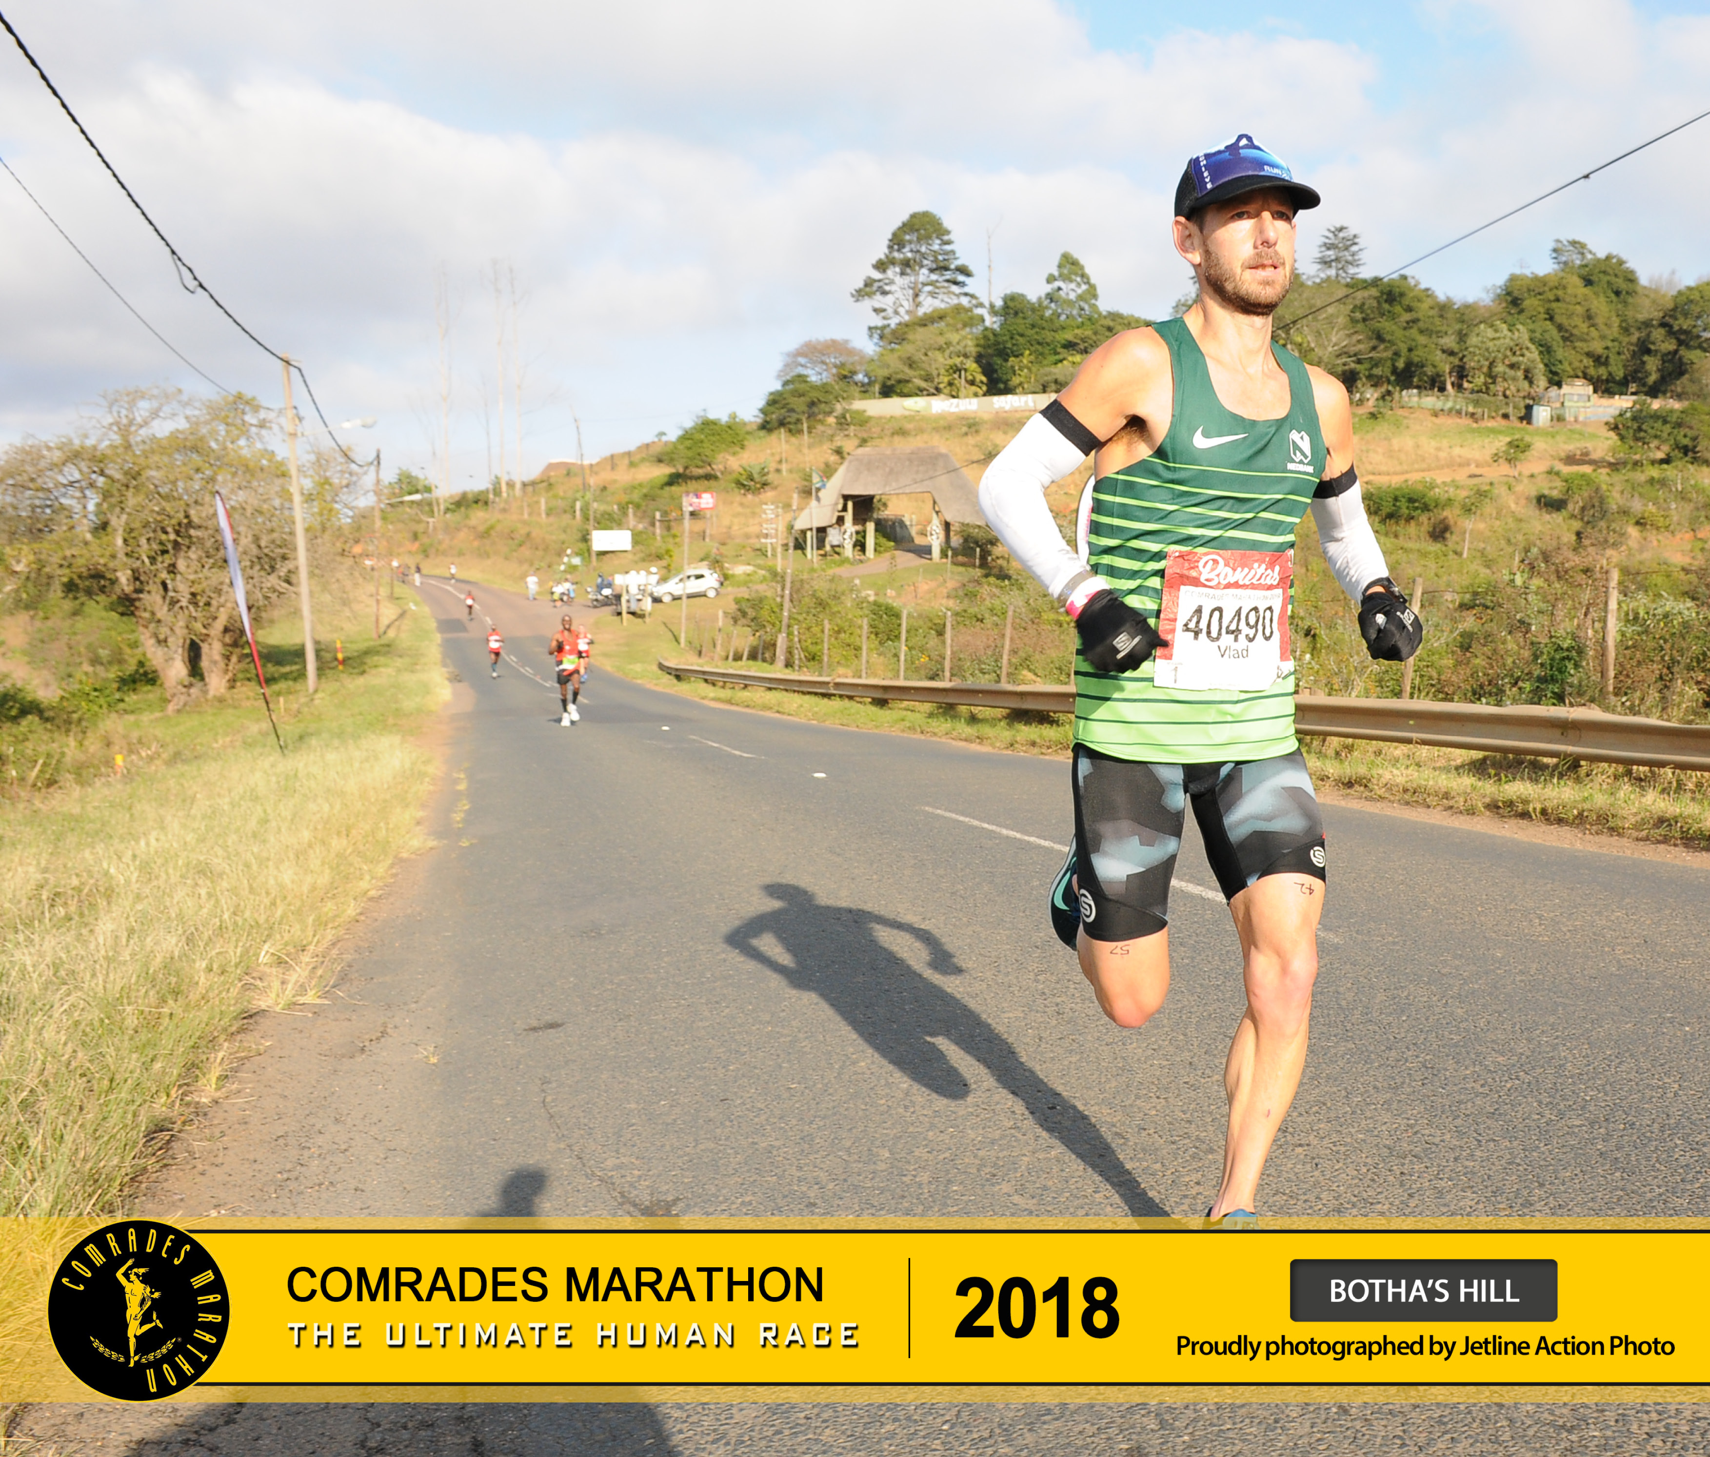

Its incredible how things are etched into your memory, the route (except the start and end) is the same every year, Id seen the course once before in last years run, yet as I progressed, there were specific little sections that I distinctly remembered from last years run, as if Id been there many times before! I was now running through the sections I was walking though last year!

And on we went. The Marathon distance had no markings, but I did see my 42km split come up on my watch, so I kept an eye on this for the next 200 metres clocking 2:38 for the Marathon distance, with plenty of hills in this first section and close to the leading runners I was feeling a relief that my training had come together.

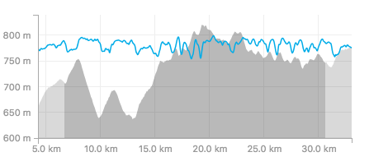
The first 35km is actually quite deceptively difficult – especially given it’s the DOWN run.

All those doubts in the final 3 to 4 weeks where fading or faded! The next significant point now was the 45km mark, as this marked close enough to the race halfway point, I was through there and heading to 50km, feeling strong! I knew that I had to get to 60km feeling pretty good and from there hang on and just absorb and deal with what was required to finish well.

I broke the race down into three lots of 30km with a goal to run 6 hours. So that’s 2 hours on average for each, and by the 60km I was still under 4 hours although that middle bit was pretty tough, it was going to be tough from now on.

The significant splits in my race strategy (Well 30 and 60, plus the other two being the Marathon and 50), show I was under my 6 hour predicted finish with some time to spare

30km: 1:50:57

(Marathon) 2:38:48

50km 3:11:10

60km: 3:51:58

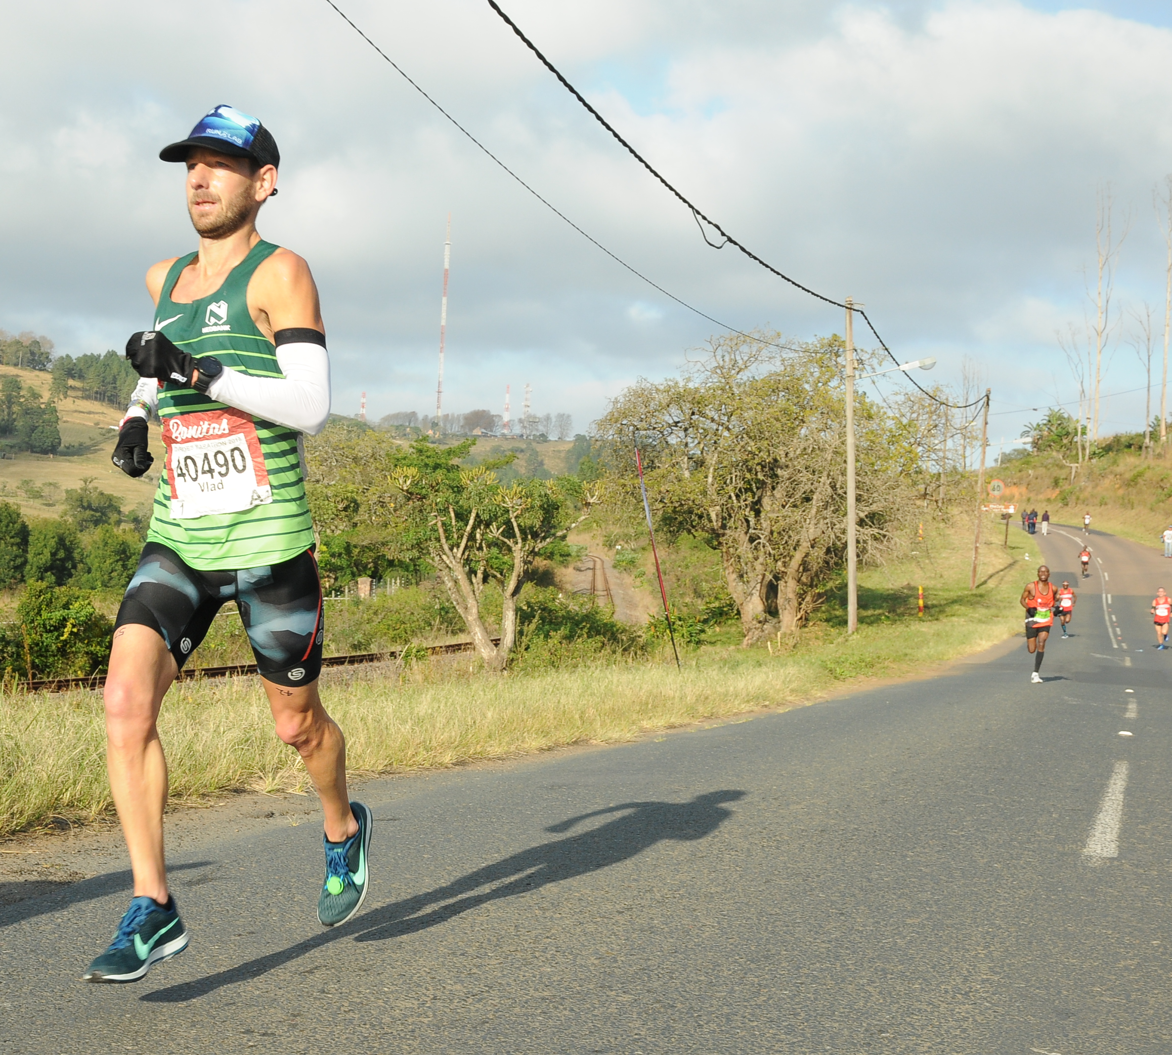

A typical course photo. Just you and a winding road

Between 60 and 70 was one of the best sections of the race, my legs kept going, and I overtook a few runners and others I passed as they pulled out. I’ve been on the other side of this though and know all too well it can change in an instant, I was wary but aggressive – walking a fine line of pushing my limits now. We also hit the start of the real DOWN. All up it was close to 7km with about 3.5km quite steep downhill. The road was now wide and highway like, it felt like we were headed into the city!

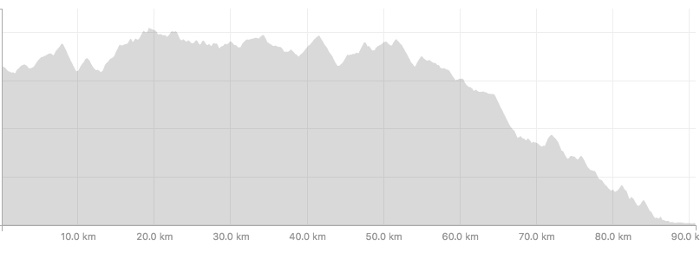
The course. Its Downhill right? Well yes it is mainly, from about 60km though!

A fault in my approach of not knowing the course like the back of my hand, was that whilst I did know that the final 30km had a lot of down, there had to be hills, and any hills now were pretty hard. Just as we past 70km, we hit a particularly nasty hill and whilst still moving well enough, it really felt so slow having come off that long descent. This was the last of the personal refreshment points that I would likely use, however as detailed in the introduction, this is where I fell over– HARD. Somehow I absorbed everything bad about it, and whilst it seemed like forever at the time, it was a few minutes lost maybe five, but dealt with on the road, as about 73km the road flattened out again and I was running ok, RELIEF .

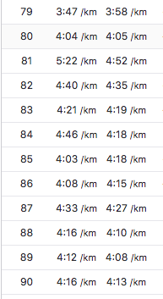

MY finishing splits, Its not great reading – but there were still a few nasty hills in this last section I distinctly remember that! No sub 4 splits after 79km and I was feeling every step. I was literally counting down the kilometres now one at a time and constantly checking my watch – I was close to getting under 6, I really wanted that - it would cap off a great run for me. My head was telling me I wasn’t but the heart wouldn’t stop and I tried and I tried and I tried but the closer I got the more I realised that I just wasn’t going to be able to do it – I was pushing every single little scrap of energy out of my legs, I was staying tall and holding form as best I could. My Runlab team was with me the whole way – I could feel the encouragement. Picture this, I was now running into a major world city on a freeway three, sometimes more lanes wide in each direction across, all blocked off , no cars, all for me as I headed too the stadium. As far as I could see I could sometimes see 1 runner, that was it. Me the freeway and a few kilometres left to run and then done.

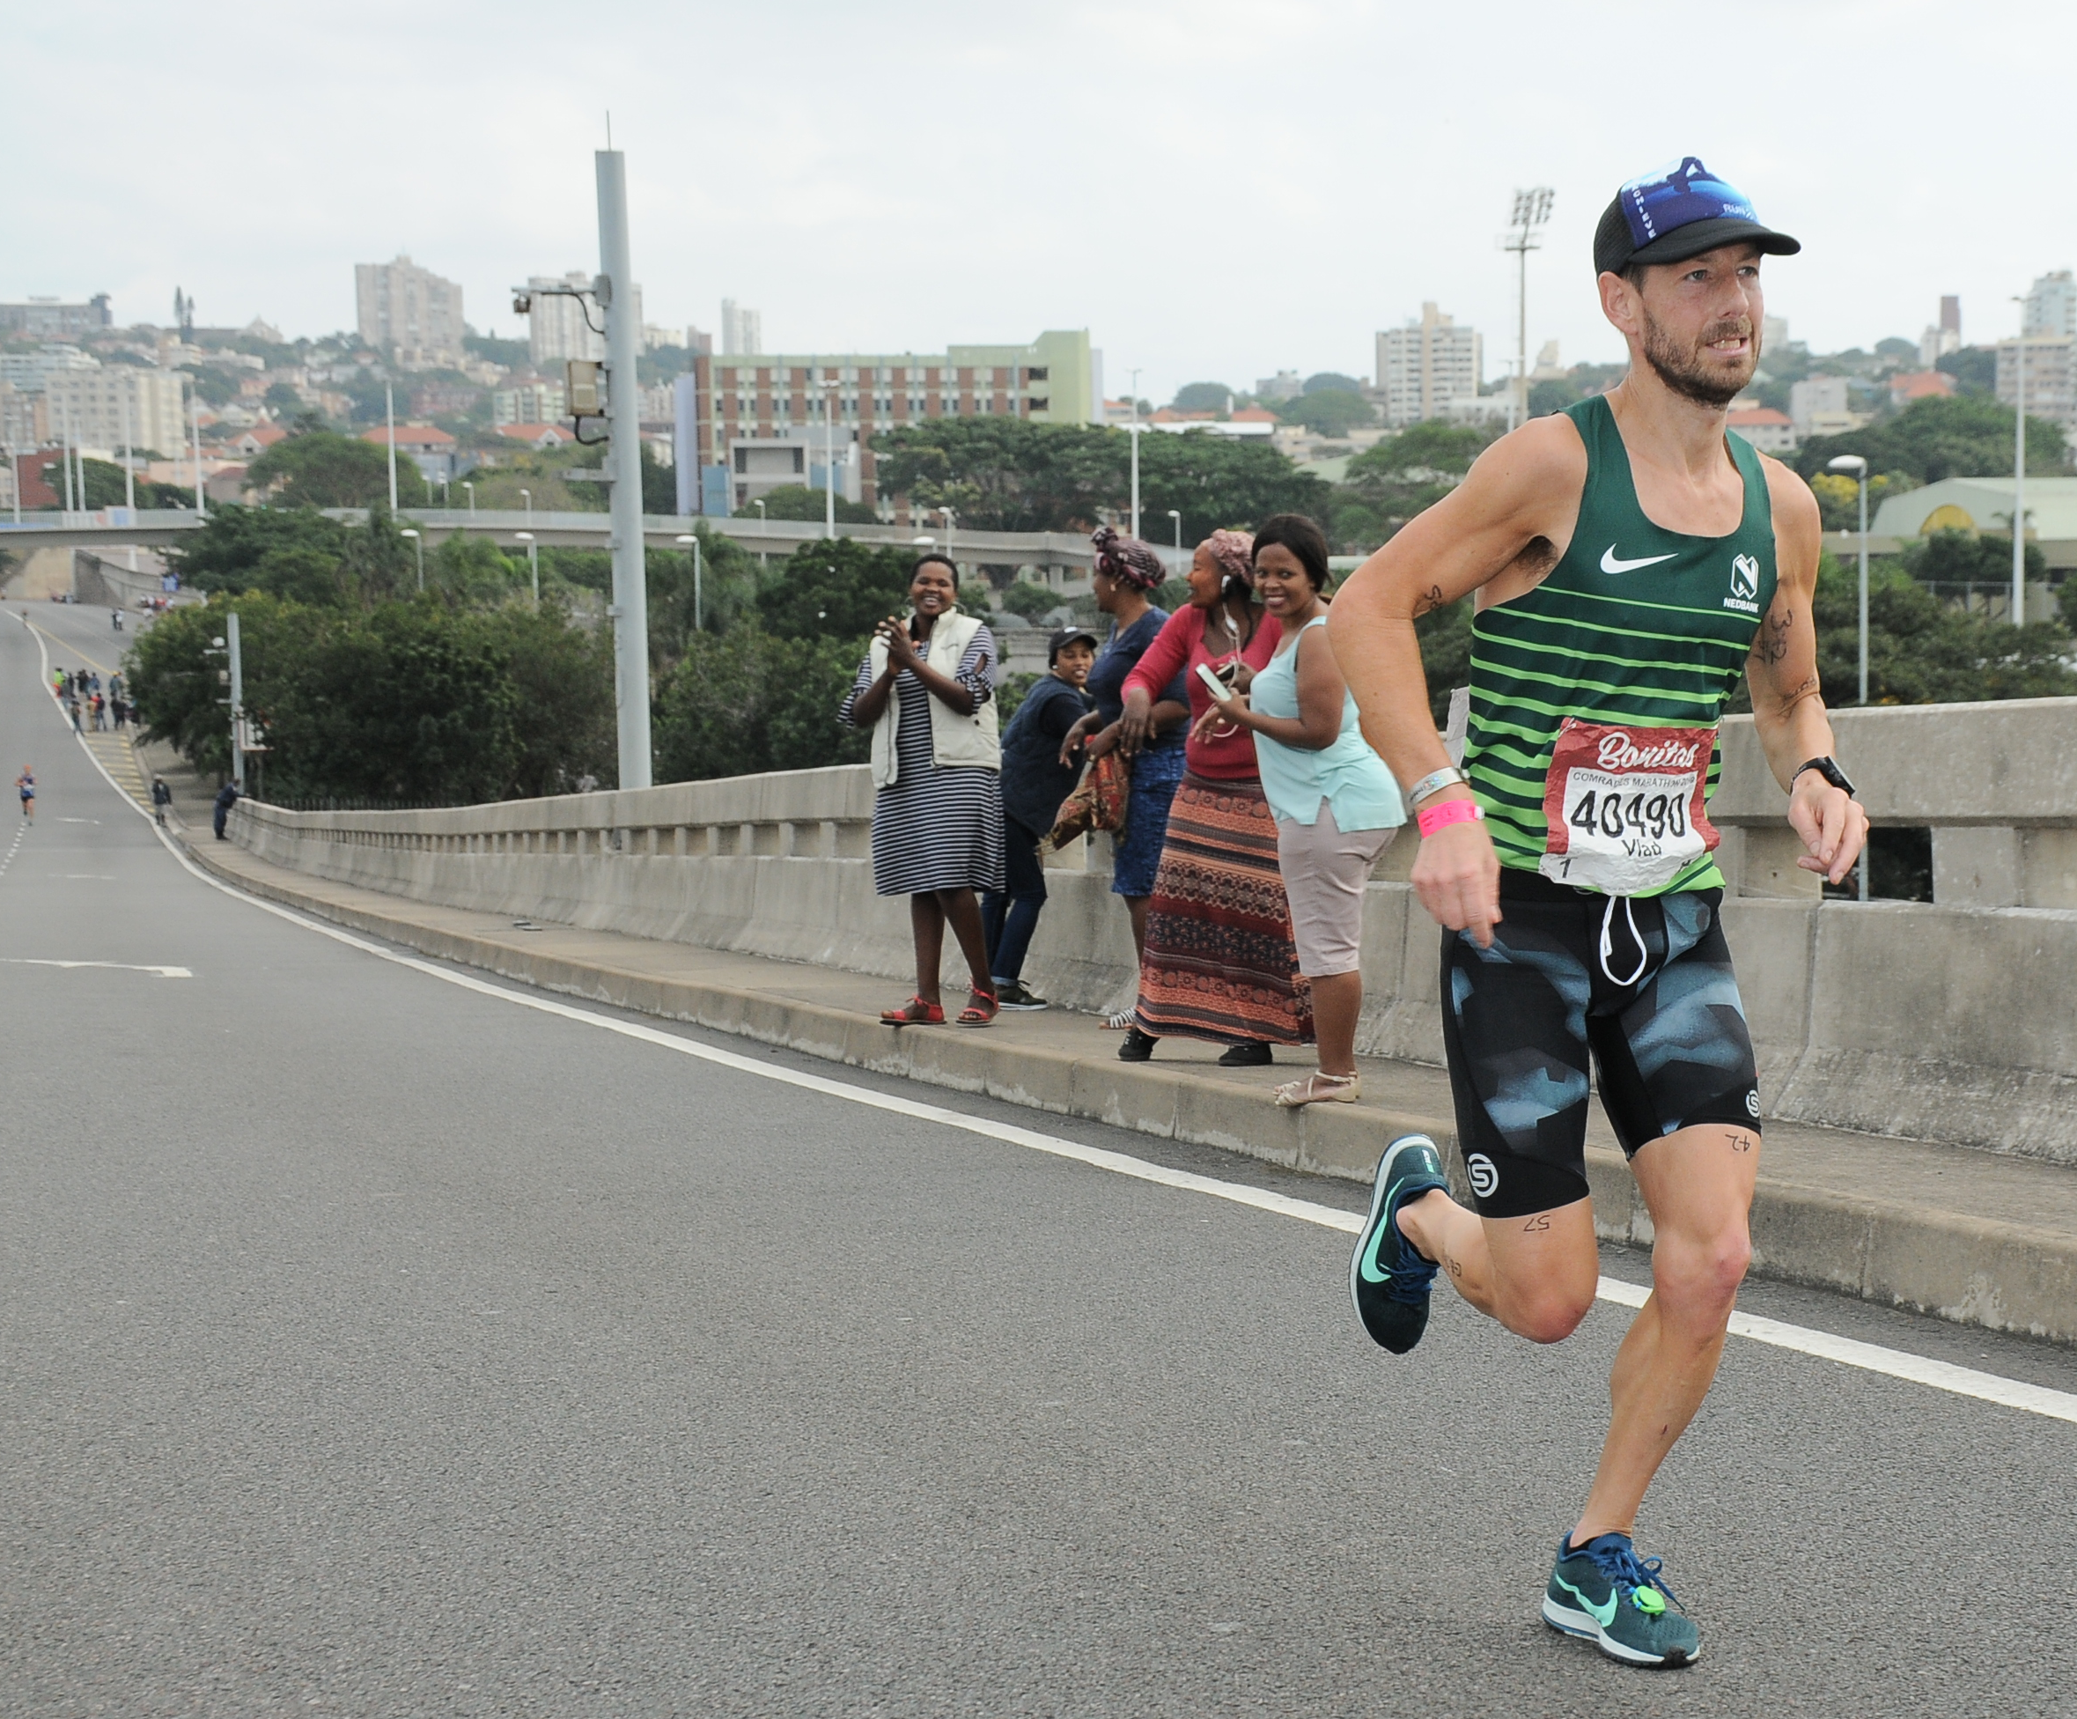

This is about 7-8km from the finish. I wanted to show what the hills/rises look like in comparison to viewing the course profile in isolation.

At the time it seems forever, but really the last 10km or so was over pretty quickly. It was very difficult and whilst mainly flat and downhill there were still some killer hills to contend with as we closed in on the finishing line. I had known from maybe 15km to go that I was about 24th overall and that was really spurring me on, but I just didn’t quite have enough energy to do anything about it as much as I tried.

The last sections of a race this large are filled with plenty of emotion, you loose control, lower your guard and let your feelings show. It’s an incredible experience. I closed in on the Stadium, passing the old finish stadium almost two kilometres sooner. I realised I couldn’t make the 6 hours on this new course but I was still so proud – I wasn’t proud of me, I actually don’t know how to write it. I was proud of the person I had been and what I could overcome and to finish in 21st was surprisingly amazing for me, a sense of real accomplishment. I know now all that stands between me and the top 10 is a bit more luck, a bit more work and another consistent preparation, and that’s all! I have the formula to be competitive at this, the toughest and most competitive Ultra marathon in the world. Who would have guessed that a few years ago? The new finish and extended course was all that had stood between me and the Wally Hayward medal, we had covered 91km

The training was good. Again I had NO Injuries only few tiny niggles here and there. I incorporated a sound recovery plan to complement my weekly running, which included:

- A weekly massage . The heavier weeks I would sometimes aim to get two massages
- A weekly “Hip Balance” as a minimum, again though on the heavier weeks and closer to the key races this was often twice weekly
- Regular Ice baths and always getting into the cold water after all long runs on a weekend!
- Careful shoe rotation. Actually just shoe rotation amongst my favourite shoes.
- Stretching once a week for 20 minutes
- Compression recovery boots minimum 3 times per week
- Strength session at least weekly – Twice on weeks with less Trail running and specifically structured to increase hip flexor strength.

You can always look to improve and whilst I was happy with the result, some small improvements would be gained I feel by being sharper and less fatigued in the 8-12 weeks prior to taking on the race again.

For me I feel best and benefit from a weekly mileage of around 190-210km but only in the strength build phase so between 306 months out. This needs to be dropped back closer to 150km a week in the final 3 months before the race allowing some better quality faster races and training sessions.

Weekly averages
December 180km/week
Jan 190km/week
Feb 190km/week
March 210km/week
April 150km/week
May 140km/week

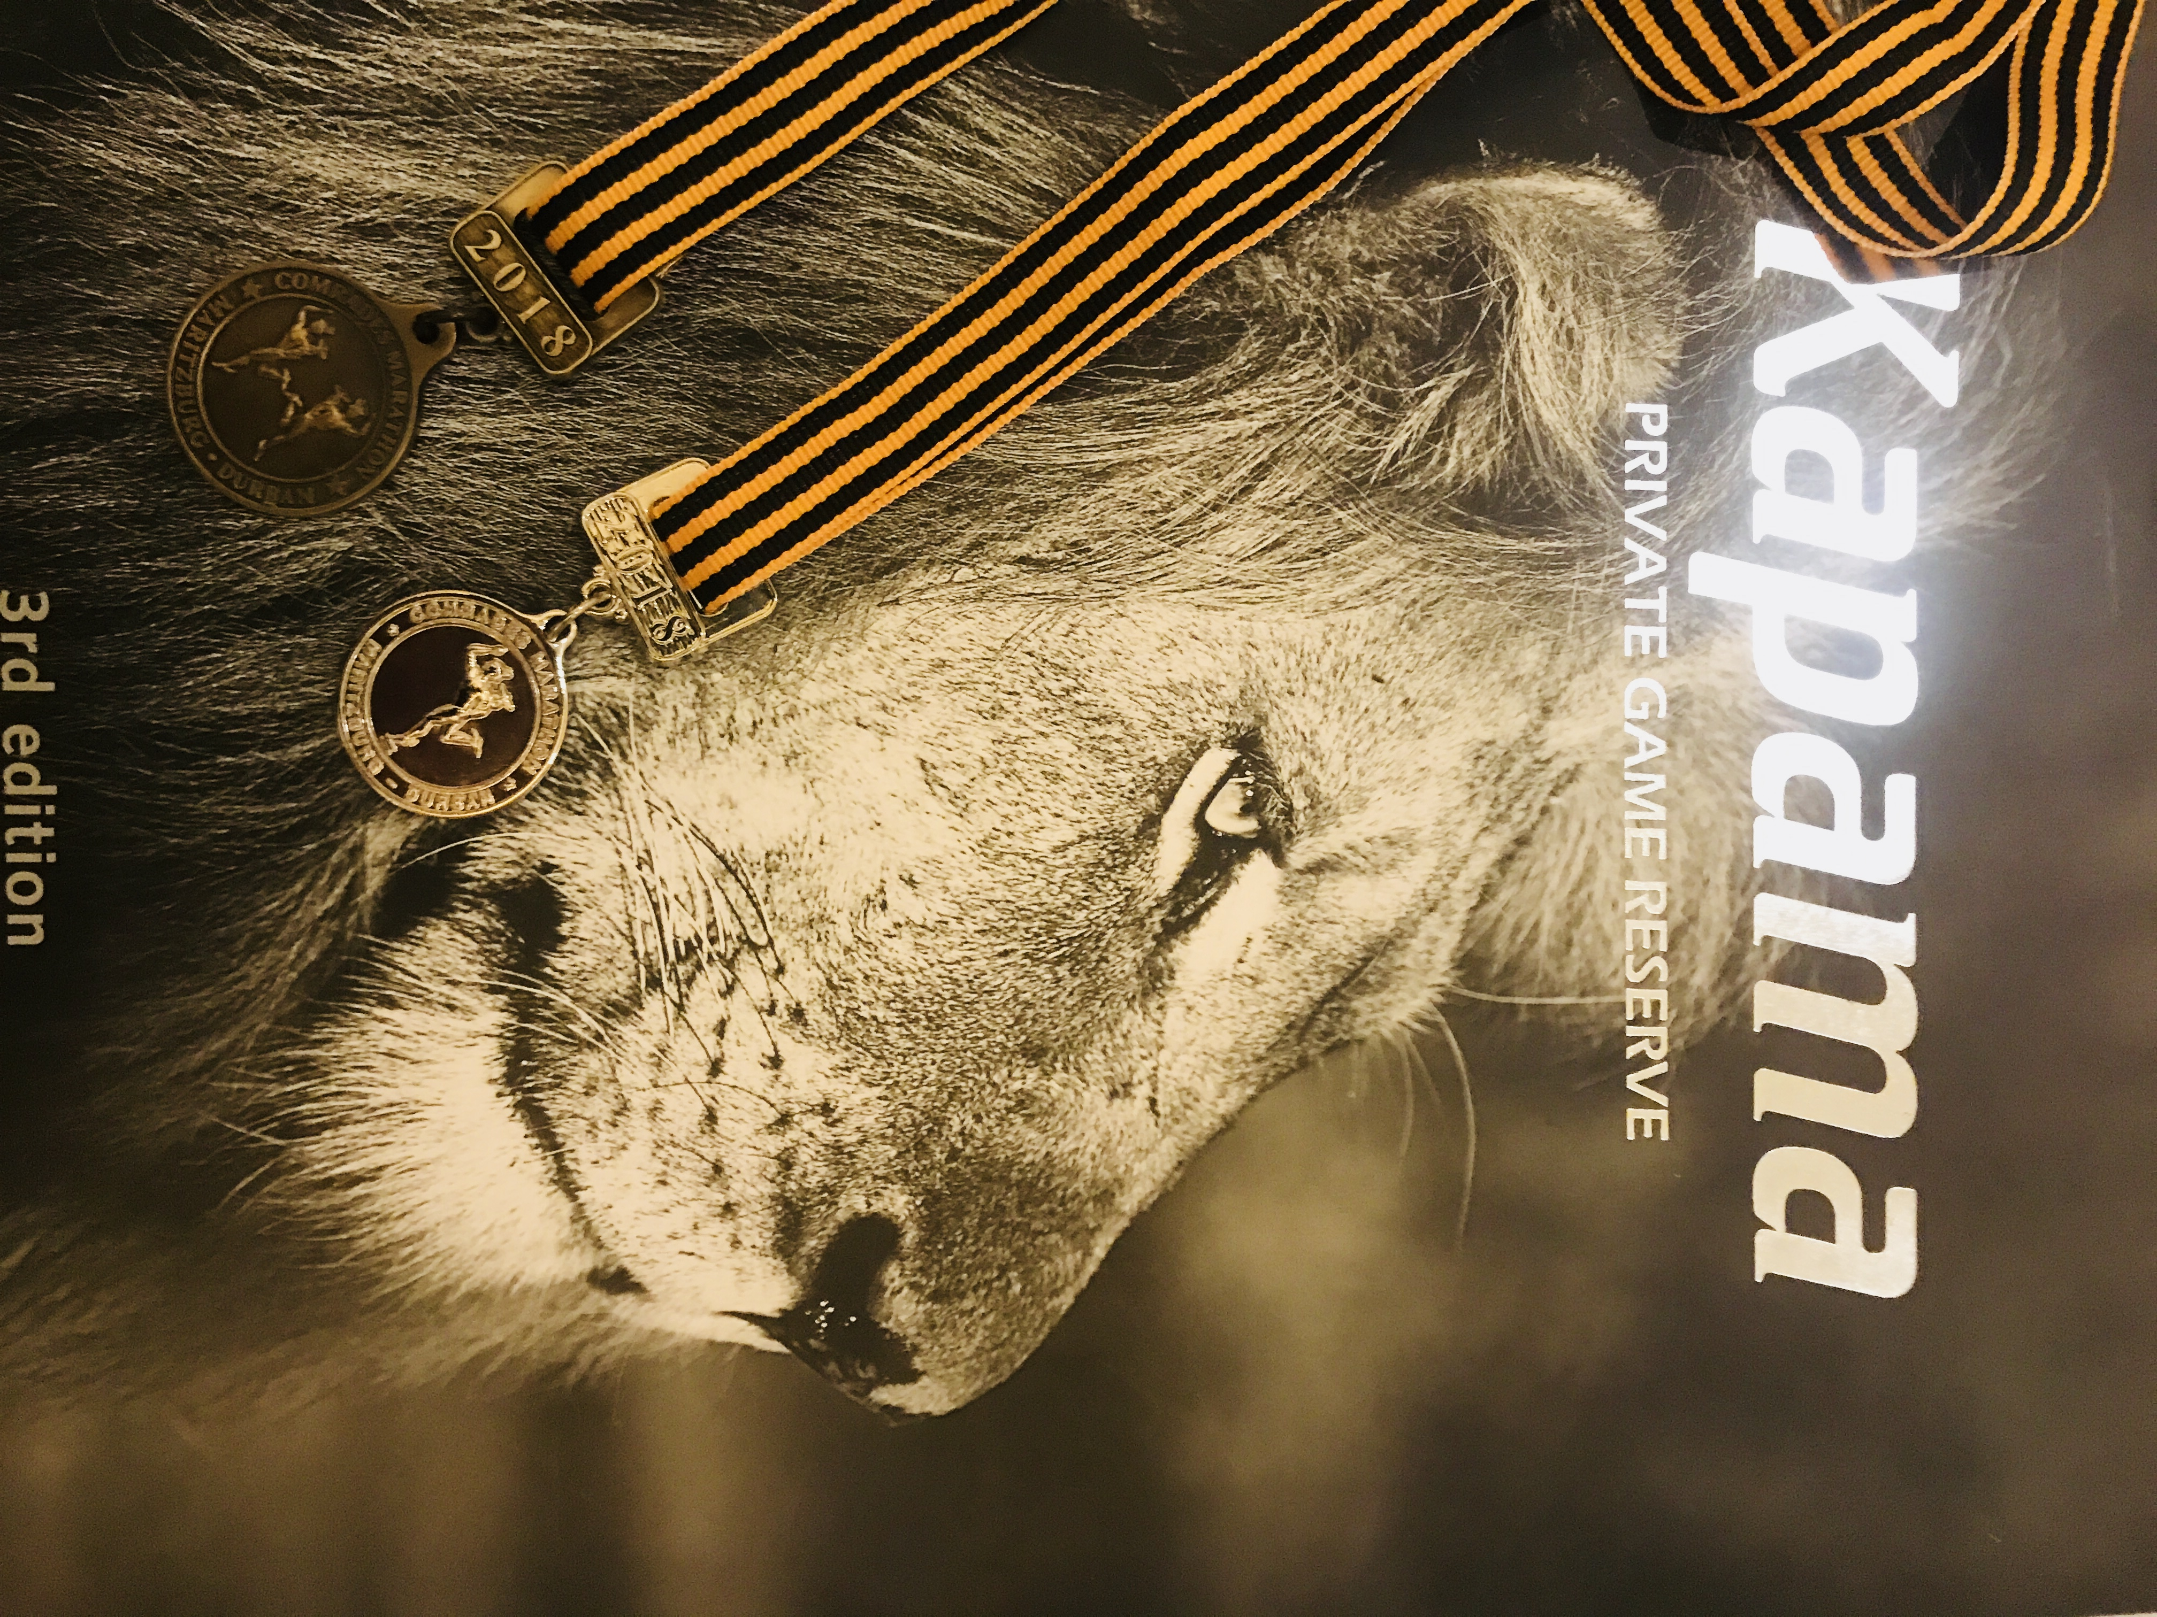

What worked well was the better adaption to the longer distances and NO Cramping or Hip flexor issues in the RACE and I ran a whole lot better! In the 12 months since last years COMRADES I ran 2 100km trail races both hard with a lot of elevation (although I hoped Tarawera would be faster but due to Weather it was a Mud fest and essentially equivalent to the GNW100’s). I also ran basically 3 50km races with two on road, these really were just training runs, and whilst the times were not quite as quick as Id planned the Gold Coast 50km was a new race record (on a course that’s got a lot of footpath and turns and on the day was very windy and warm) . In Canberra I was 1st too claiming the 50km national title in 3:05 again in difficult conditions this time due to the wind and cold. 6 Foot Track would have to also be classified as essentially a 50km race a back2back 1st was a great result with the volume I was hitting, but as alluded to above my run was left too late I feel compromising recovery and speed. The Sydney 10 and UTA 22 in particular were frustrating runs. UTA was definitely the worst I’ve ever felt in a running race in terms of my body’s ability to push or drive at all, that day I gave everything I had but had nothing.

Huh! So Close to 6 hours, but I’m ok with it. Phew, what a day!

The rest of my time in South Africa was incredible deserving of a separate write-up so ill leave that for another day. Needless to say we met amazing people in amazing places and got to see the real South Africa. I will be back!

Now my plan is a small recovery training break and either another A race in November or December. I’m aiming for the North Face50 or Ultra Trail Capetown. Next year opens up a little bit and I think there will be plenty of crazy trail running events and a few quicker Marathons before I go for gold in 2020 at Comrades.

I have to give a massive shout out to everyone in Runlab that got behind me and for all the messages of support and love, thankyou so much! Cheryl deserves my medals again; I got two, maybe ill give her one . But Cheryl herself had an amazingly good run and incredible experience and it was great to have her along for this event, thanks for everything!

There are many people that are a part of this journey every year and thanks for being on my team!

Shout out to the legends that are Aviano, Lebent, Transitions Chiropractic, UpnAdam, Isowhey, Air relax AND Salomon and Suunto. Thanks to Nick and Adrian and team Nedbank over in South Africa for accepting me onto the team!

