TERM 2 2018 – FACT SHEET

Term 2 starts week of Monday 23rd April*

Welcome back to our regular runners, and the sincerest of welcome’s to those just starting the Runlab journey. I’m Vlad Shatrov from Runlab. Runlab is about bringing quality run training sessions to runners striving to perform at their potential. Summarised by our favourite quote “Achieveyourimpossible”.

We offer a number of different types of run sessions (Mytrailgroup and Myrungroup) and run related sessions (Runstrong, Run recovery and Run yoga), which complement you running.

My personal running journey and associated education can be found by following these pages
Instagram: Vladdy_runlab https://www.instagram.com/vladdy_runlab/
Twitter: @runlabvlad
Facebook: https://www.facebook.com/VladShatrovRunner/

* Saturday Trails and Budgewoi Myrungroup start earlier in Term 2. Saturday Trails Sat 7th and Budgewoi Myrungroup Tuesday 10th.

What’s new this Term?

As always, every Term there is additions and alterations. We have the following changes in Term 2, 2018.

Myrungroup
- Budgewoi will commence its Term 2 on Tuesday 10th April (2 weeks before all other groups) however it still runs for 10 weeks, hence finishing 2 weeks before the other groups
- Thursday Sutherland group is currently on hold, although we hope it re-commences in Term 2

Runstrong
- We have added a Monday 5:45am session at the Concept – Highfields in the Hunter
- The Monday Runstrong Class* with Adam from UpnAdam performance training will commence at 7pm, 15 minutes earlier than its current 7:15pm start.
- The Wednesday Runstrong Class* with Vlad from Runlab will commence at 5:30pm, 15 minutes earlier than its current timeslot at 5:45pm. There is an easy run prior to RUNSTRONG everyone is welcome. We cover approximately 6km. head torches required in Terms 2 and three. We also have access to ICE-BATHs post session which is great to take advantage of. So bring your towels and a warm change of clothes, Making the Wednesday evening the ultimate session!
- Sydney Thursday Broadway session remains at 6:ooam
- *The Monday and Wednesday classes run for up to 75 minutes with a specific focus on DEEP ENGAGEMENT and STRENGTH (Upnadam) and ENDURANCE and RUNNING EFFICIENUCY (Vlad-Runlab) – These sessions are longer and more advanced then our regular sessions and as such can only be attended if you have been a regular Runstrong client and/or by getting clearance from the relevant trainer.

Mytrailgroup
- Maroubra will remain a Mytrailgroup
- The Saturday Sydney and Thursday Hunter sessions return in Term 3
- The Hunter Mytrailgroup will run for 5 sessions in total – Over 6 weeks. Leading up to Ultra Trail Australia. (Like the Budgewoi group) there is no break in term for this group and its scheduled on the following weeks
  - 7th, 14th, 28th April and 5th, 12th May
  - A 5 PASS or Casual sessions are available if the limit of 24 is not reached by those taking up a 5 Pass

Runrecovery/Runyoga
- Returns later in 2018

All our other sessions and groups are as per last term and/or scheduled.

Please note ALL MYRUNGROUP runners wear a running head torch in Terms 2 and three for your own safety and so others can see you.

Upcoming events

SINGLE TRAINING DAYS. We call these Super sessions. We hold these in multiple locations throughout the year as “One off” sessions. Each one is unique and has a specific purpose. In Term 2 we have the following supersession planned
APRIL ULTRA SESSION – April 20-21-22 – Register now and check in here
http://runlab.com.au/events/1-day-super-sessions/

Session Costs and Packages?
Sessions and access to the benefits cost from as little as $11.90 per session with multiple options available

A Myrungroup Term is $209 for 1 session per week for 10 weeks
Add the Double up option for $59 to do 2 sessions of Myrungroup a week.
This is the same for Runstrong and the Tuesday Maroubra Mytrailgroup.

If you Mix and Match (i.e. choose 2 different types of sessions such as Myrungroup and Runstrong) please ensure you select the correct payment options. I.e. if you do a Myrungroup and a Runstrong a week it will be $209 plus $159. If you do Mytrailgroup and Myrungroup they are also classified as different session types and you can select the $50 discount for the later.

The exception Mytrailgroup Maroubra where customers can do this for $209 and add another Myrungroup for $59.

Saturday Mytrailgroup!

Hunter only in Term 2
5 Casual sessions $35/5 pass $139.

Note: Doing the 5 Pass option in the Hunter WILL NOT qualify you for taking an additional full Term of Myrungroup for the $159 option, the $209 option is to be used here.

Stand-alone Run recovery and Run Yoga are $149 per Term. If one or both of these classes are attended and you already do Myrungroup/Mytrailgroup/Runstrong they can be added for only $99 a term.

Young Guns our run session for those runners between the ages of 8 to 13 is $129 a Term, with double options also available for an additional $49.

NEW RUNNERS PROCESS
- Setup your profile on the Runlab registration platform here https://clients.mindbodyonline.com/classic/ws?studioid=181924
(We use Mindbody)
- Purchase your services to attend your groups
- Book into your classes with your credit – select recurring to book for the whole Term
- ADD your $49 ($44 Young Guns) or $54 joining fee (that’s a once off) – This is found under online store Joining fee. The $49 gives you this racer back singlet http://runlab.com.au/product/runlab-training-singlet-women/
and the $54 gives you this wider back singlet. http://runlab.com.au/product/runlab-trail-singlet/
There are of course mane and women’s cuts.

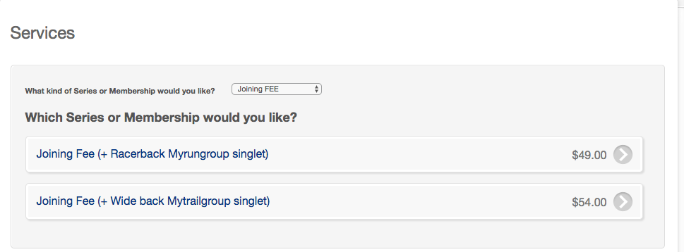
- Email info@runlab.com.au telling us your preferred training singlet size so we can get this to you at the start or the Term

RETURNING RUNNERS
Ensure you complete Steps 2 AND 3 above please!

How to stay updated?

This is one of the most important sections for all our runners. Whilst we have a “usual” session location and or time for our groups, there are weeks where we may change the location slightly to best undertake a specific session, or we may also be forced t make a change due to the weather for example. Keeping this in mind will ensure that you don’t miss these notifications.

1, Weekly E News. When you register (And provide your email) this is added to the Weekly runners list. Every Friday or Saturday in the Term you will get an update from the week gone and the upcoming week. So please check that you provide your best email address and ensure this doesnt go to your junk email folder.
2. Runlab Website
The website www.runlab.com.au contains information on everything Runlab. The Homepage has a Timetable on it (That’s the standard usual timetable) directly below this is a blue box, ANY changes to the usual location are also listed here.

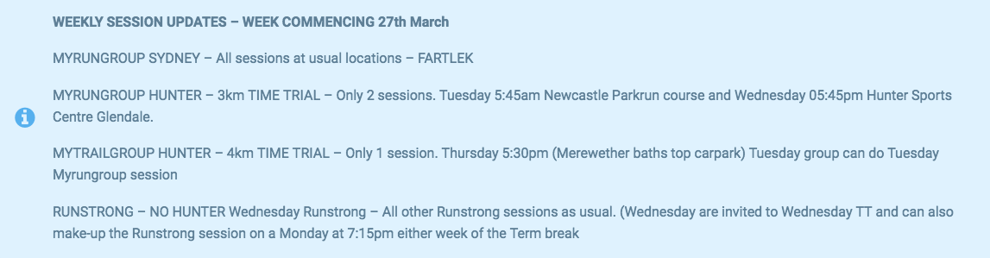

2. Social Media.
All groups have a Facebook page. Additionally there is a main Runlab Facebook page. “Liking both of these” is suggested.

3. There is a Runlab APP available on the APP store. You can also use this for booking your Runlab sessions and paying for your classes too. If you enable notifications we can send you instant notifications, which we do for important updates. It looks like this.

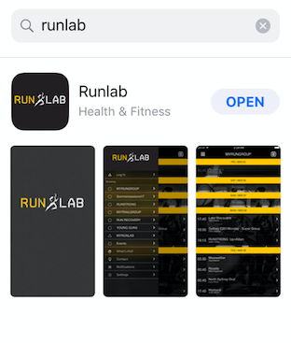

4. Social
Instagram: https://www.instagram.com/runlabhq/
Twitter:RunlabHQ
Facebook: https://www.facebook.com/MyRunlab/ is the main page. Then each group has its own page, which is worth “Liking”

Session types?

See more detail on our specific sessions by following the links

MYRUNGROUP
http://runlab.com.au/myrungroup/

MYTRAILGROUP
http://runlab.com.au/mytrailgroup/

RUNSTRONG
http://runlab.com.au/runstrong/

MYRUNGROUP - ELITE
http://runlab.com.au/myrungroup/

YOUNG GUNS
http://runlab.com.au/myrungroup/young-guns/

RUN RECOVERY
http://runlab.com.au/run-recovery/

RUN YOGA
http://runlab.com.au/run-yoga/

Term 2 Timetable

http://runlab.com.au/running-groups/myrungroup/timetable/

The online store

We have an online store, which is always being updated. In late term 1 we released a lifestyle range to complement our performance apparel. This and all our items can be viewed and purchased here. Shipping can be waived at the payment page and you can email us for group collection if you wish. Note – New customers het the Black/Yellow Runlab training singlet as part of their joining fee.

Joining

To book into the term and manage your sessions go to the Enrol button on the top menu of the Runlab website, or select any of the “Enrol” links on the other website pages. This will allow you to create a profile and register for the term by purchasing your desired running groups /services. You will return here to manage any future purchases and services. This account management and registration platform is run through a third party provider “Mind body online” and payment references show as EZIDEBIT (On your bank statement).
http://runlab.com.au/enrol/

The 3 Step enrol process

1. Choose your group/s and create your profile
When you have decided on your desired groups and how you want to pay (i.e. straight up or Contracts) simply access your Runlab Mind body profile https://clients.mindbodyonline.com/classic/ws?studioid=181924. Setup a profile (if you are new) and book your desired classes.

2. Pay for your group/s

Once off Joining Fee
There is a “one off” $49 Joining fee for new Runlab customers. Included in this you will receive the Black and Yellow technical running training singlet. We will also capture your runners profile to share with the Coach of your group allowing an understanding of your exercise history but more importantly in a position to maximise your desired outcomes. If joining a full term for the first time add the joining fee go to online store/Services/Appointments and select the $49 Joining fee. Post registration if you have joined for the first time please email info@runlab.com.au with your desired singlet size and we will arrange for it to be available at your first group session.

Go ahead and purchase your other desired services either through upfront payment for the entire term or setting up the appropriate level membership (Further explained below)

3. Enter your group
The last step is then adding yourself to a class. This is the most important step, especially in the first week of a Term. Buying your group gives you credits, these credits are used to attach yourself to a class – See the Schedule. This allows us here at Runlab to see how many people are going to each of the sessions.

Types of Contracts explained
To book your desired classes you can either pay for the entire term of 11 weeks upfront or choose the contract option.

If you choose the contract option there are up to four levels. Each level allows you to pay in either monthly payments (3 times) or weekly repayments (12 times), the difference in price paying by contract as compared to straight up are marginally more expensive. After the 3 months the contract expires and will need to be purchased again the following term. The contract levels are. IF YOU ARE DOING MYTRAILGROUP in any format except the Maroubra Tuesday session, you cannot pay for this with contracts! You either have to pay Casual or the full Term. However if you’re doing Mytrailgroup Contracts can still be used for your other Runlab sessions.

BASE
Base is if you only do 1 session a week. This can be Myrungroup or Runstrong. Base Monthly is if you want to pay the term over 3 Monthly pays. Base Weekly is if you want to split over 12 weekly pays.

PROGRESS
Progress is if you only do 2 same sessions a week. This can be 2 Myrungroup or 2 Runstrong sessions per week as an example Progress Monthly is if you want to pay the term over 3 Monthly pays. Progress Weekly is if you want to split over 12 weekly pays.

EXCEL
Excel is if you only do 2 different sessions a week. This can be Myrungroup and Runstrong for example. Excel Monthly is if you want to pay the term over 3 Monthly pays. Excel Weekly is if you want to split over 12 weekly pays

REAL VALUE. RUNLAB MEMBER BENEFITS & PARTNER OFFERS

By signing up to a Term you are automatically eligible to receive the impressive benefits that are a part of being a RUNLAB member. Along with the structure and delivery of our sessions this sets us apart from other running groups. Benefits include:

Discounted race entries to those events we are the official training partners for including Sydney Harbour 10km/5km, Blackmore’s Sydney Running Festival, iStadium Run Newcastle and ITrail Run Glenrock, Thunderbolt Trail race and more

We will continue to offer Partner benefits. These are always being updated and will be fully updated for the start of the term.
http://runlab.com.au/partners/

TIME TRIAL SUPER SESSIONS

At the end of the Term (scheduled to best fit in with in with any possible targeted events) we run one 3km time trial only per area. We do this to allow for as many runners as possible to come together and run against eahother in a friendly competetive environment. It also allows runners to meet runners from other groups that they wouldn’t necessarily see through a term

Dates are communicated within weeks 1-5 of the Term so that you have time to be organised for that week.

Thanks to our valued partners we have an allocation of prizes awarded in the Term ending super session. The value of these packs is significant and can range up to over $300 in value. Now that’s pretty special. For each of the three groups Sydney CBD, Sydney South and Newcastle we have a minimum of Male/Female Time trial winners AND 2 coaches awards*. The award changes based on partner allocation.

*Time Trial and Coach awards terms and conditions
Cannot win fastest TT in consecutive terms and once yearly!
If your in the Elite group your time wont impact other runners receiving fastest TT and you will receive a separate award at Runlabs discretion and there may or may not be separate Elite awards.
Must have entered a full term (not casual) AND enter the following Term when the prizes will be given
Super session – there must be a minimum of 3 Male and 3 Female runners for awards to be allocated to that group.

TERMS AND CONDITIONS
http://runlab.com.au/myrunlab/faq/

